**Assignment No 5**

**Title:** Setup Single Node Kubernetes Cluster with Minikube.

**Theory:**

* **What is Kubernetes?**

Kubernetes is a portable, extensible, open-source platform for managing containerized workloads and services, that facilitates both declarative configuration and automation. It has a large, rapidly growing ecosystem. Kubernetes services, support, and tools are widely available.

The name Kubernetes originates from Greek, meaning helmsman or pilot. Google open-sourced the Kubernetes project in 2014. Kubernetes combines [over 15 years of Google's experience r](https://kubernetes.io/blog/2015/04/borg-predecessor-to-kubernetes/)unning production workloads at scale with best-of-breed ideas and practices from the community

* **Why you need Kubernetes and what it can do**

Containers are a good way to bundle and run your applications. In a production environment, you need to manage the containers that run the applications and ensure that there is no downtime. For example, if a container goes down, another container needs to start. Wouldn't it be easier if this behavior was handled by a system?

That's how Kubernetes comes to the rescue! Kubernetes provides you with a framework to run distributed systems resiliently. It takes care of scaling and failover for your application, provides deployment patterns, and more. For example, Kubernetes can easily manage a canary deployment for your system.

Kubernetes provides you with:

* **Service discovery and load balancing**
* **Storage orchestration**
* **Automated rollouts and rollbacks**
* **Automatic bin packing**
* **Self-healing**
* **Secret and configuration management**
* **Kubernetes Components**

When you deploy Kubernetes, you get a cluster.

A Kubernetes cluster consists of a set of worker machines, called [nodes,](https://kubernetes.io/docs/concepts/architecture/nodes/#_blank) that run containerized applications. Every cluster has at least one worker node.

The worker node(s) host the [Pods t](https://kubernetes.io/docs/concepts/workloads/pods/#_blank)hat are the components of the application workload. The [control plane](https://kubernetes.io/docs/reference/glossary/?all=true#_blank) manages the worker nodes and the Pods in the cluster. In production environments, the control plane usually runs across multiple computers and a cluster usually runs multiple nodes, providing fault-tolerance and high availability.

This document outlines the various components you need to have a complete and working Kubernetes

cluster.

Here's the diagram of a Kubernetes cluster with all the components tied together.

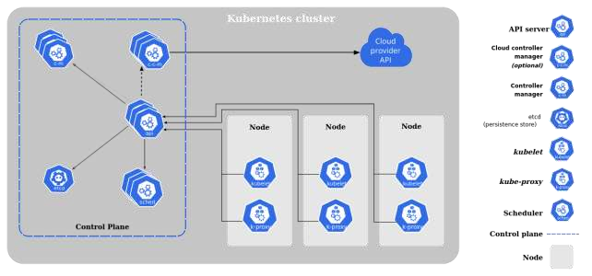

* **Kubernetes Architecture**

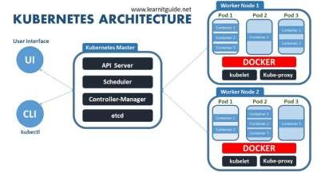

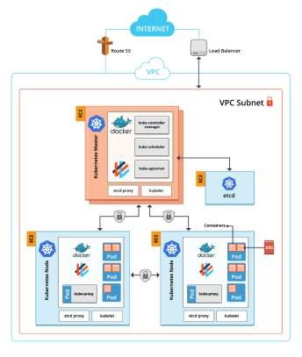**Kubernetes Architecture on AWS:**

* **Control Plane Components**

The control plane's components make global decisions about the cluster (for example, scheduling), as well as detecting and responding to cluster events (for example, starting up a new [pod w](https://kubernetes.io/docs/concepts/workloads/pods/#_blank)hen a deployment's replicas field is unsatisfied).

Control plane components can be run on any machine in the cluster. However, for simplicity, set up scripts typically start all control plane components on the same machine, and do not run user containers on this machine. See [Building High-Availability Clusters f](https://kubernetes.io/docs/admin/high-availability/)or an example multi-master-VM setup.

1. **kube-apiserver**

The API server is a component of the Kubernetes [control plane t](https://kubernetes.io/docs/reference/glossary/?all=true#_blank)hat exposes the Kubernetes API. The API server is the front end for the Kubernetes control plane.

The main implementation of a Kubernetes API server is [kube-apiserver.](https://kubernetes.io/docs/reference/generated/kube-apiserver/) kube-apiserver is designed to scale horizontally—that is, it scales by deploying more instances. You can run several instances of kube-apiserver and balance traffic between those instances.

1. **etcd**

Consistent and highly-available key value store used as Kubernetes' backing store for all cluster data.

If your Kubernetes cluster uses etcd as its backing store, make sure you have a [back up p](https://kubernetes.io/docs/tasks/administer-cluster/configure-upgrade-etcd/#backing-up-an-etcd-cluster)lan for those data.

You can find in-depth information about etcd in the official [documentation.](https://etcd.io/docs/)

1. **kube-scheduler**

Control plane component that watches for newly created [Pods w](https://kubernetes.io/docs/concepts/workloads/pods/#_blank)ith no assigned [node,](https://kubernetes.io/docs/concepts/architecture/nodes/#_blank) and selects a node for them to run on.

Factors taken into account for scheduling decisions include: individual and collective resource requirements, hardware/software/policy constraints, affinity and anti-affinity specifications, data locality, inter-workload interference, and deadlines.

1. **kube-controller-manager**

Control Plane component that runs [controller p](https://kubernetes.io/docs/concepts/architecture/controller/#_blank)rocesses.

Logically, each [controller i](https://kubernetes.io/docs/concepts/architecture/controller/#_blank)s a separate process, but to reduce complexity, they are all compiled into a single binary and run in a single process.

These controllers include:

* + Node controller: Responsible for noticing and responding when nodes go down.
  + Replication controller: Responsible for maintaining the correct number of pods for every replication controller object in the system.
  + Endpoints controller: Populates the Endpoints object (that is, joins Services & Pods).
  + Service Account & Token controllers: Create default accounts and API access tokens for new namespaces.

1. **cloud-controller-manager**

A Kubernete[s control plane c](https://kubernetes.io/docs/reference/glossary/?all=true#_blank)omponent that embeds cloud-specific control logic. The cloud controller manager lets you link your cluster into your cloud provider's API, and separates out the components that interact with that cloud platform from components that just interact with your cluster.

The cloud-controller-manager only runs controllers that are specific to your cloud provider. If you are running Kubernetes on your own premises, or in a learning environment inside your own PC, the cluster does not have a cloud controller manager.

As with the kube-controller-manager, the cloud-controller-manager combines several logically independent control loops into a single binary that you run as a single process. You can scale horizontally (run more than one copy) to improve performance or to help tolerate failures.

The following controllers can have cloud provider dependencies:

* Node controller: For checking the cloud provider to determine if a node has been deleted in the cloud after it stops responding
* Route controller: For setting up routes in the underlying cloud infrastructure
* Service controller: For creating, updating and deleting cloud provider load balancers

➢ **Node Components**

Node components run on every node, maintaining running pods and providing the Kubernetes runtime environment.

1. **kubelet**

An agent that runs on each [node i](https://kubernetes.io/docs/concepts/architecture/nodes/#_blank)n the cluster. It makes sure that [containers a](https://kubernetes.io/docs/concepts/overview/what-is-kubernetes/#_blank)re running in a [Pod.](https://kubernetes.io/docs/concepts/workloads/pods/#_blank)

The kubelet takes a set of PodSpecs that are provided through various mechanisms and ensures that the containers described in those PodSpecs are running and healthy. The kubelet doesn't manage containers which were not created by Kubernetes.

1. **kube-proxy**

kube-proxy is a network proxy that runs on eac[h node i](https://kubernetes.io/docs/concepts/architecture/nodes/#_blank)n your cluster, implementing part of the Kubernete[s Service](https://kubernetes.io/docs/concepts/services-networking/service/#_blank) concept.

[kube-proxy](https://kubernetes.io/docs/reference/command-line-tools-reference/kube-proxy/) maintains network rules on nodes. These network rules allow network communication to your Pods from network sessions inside or outside of your cluster.

kube-proxy uses the operating system packet filtering layer if there is one and it's available. Otherwise, kube-proxy forwards the traffic itself.

1. **Container runtime**

The container runtime is the software that is responsible for running containers.

Kubernetes supports several container runtimes: [Docker,](https://docs.docker.com/engine/#_blank) [containerd,](https://containerd.io/docs/#_blank) [CRI-O,](https://cri-o.io/#_blank) and any implementation of the [Kubernetes CRI (Container Runtime Interface).](https://github.com/kubernetes/community/blob/master/contributors/devel/sig-node/container-runtime-interface.md)

➢ **Pods**

*Pods* are the smallest deployable units of computing that you can create and manage in Kubernetes.

A *Pod* (as in a pod of whales or pea pod) is a group of one or more [containers,](https://kubernetes.io/docs/concepts/containers/) with shared storage/network resources, and a specification for how to run the containers. A Pod's contents are always co-located and coscheduled, and run in a shared context. A Pod models an application-specific "logical host": it contains one or more application containers which are relatively tightly coupled. In non-cloud contexts, applications executed on the same physical or virtual machine are analogous to cloud applications executed on the same logical host.

* **Using Pods**

Usually you don't need to create Pods directly, even singleton Pods. Instead, create them using workload resources such as [Deployment o](https://kubernetes.io/docs/concepts/workloads/controllers/deployment/#_blank)r [Job.](https://kubernetes.io/docs/concepts/workloads/controllers/job/#_blank) If your Pods need to track state, consider the [StatefulSet r](https://kubernetes.io/docs/concepts/workloads/controllers/statefulset/#_blank)esource.

Pods in a Kubernetes cluster are used in two main ways:

* + **Pods that run a single container**. The "one-container-per-Pod" model is the most common Kubernetes use case; in this case, you can think of a Pod as a wrapper around a single container; Kubernetes manages Pods rather than managing the containers directly.
  + **Pods that run multiple containers that need to work together**. A Pod can encapsulate an application composed of multiple co-located containers that are tightly coupled and need to share resources. These co-located containers form a single cohesive unit of service—for example, one container serving data stored in a shared volume to the public, while a separate *sidecar* container refreshes or updates those files. The Pod wraps these containers, storage resources, and an ephemeral network identity together as a single unit.

* **Service**

An abstract way to expose an application running on a set of [Pods a](https://kubernetes.io/docs/concepts/workloads/pods/#_blank)s a network service.

With Kubernetes you don't need to modify your application to use an unfamiliar service discovery mechanism. Kubernetes gives Pods their own IP addresses and a single DNS name for a set of Pods, and can load-balance across them.

* **Ingress**

**FEATURE STATE:** Kubernetes v1.19 [stable]

An API object that manages external access to the services in a cluster, typically HTTP.

Ingress may provide load balancing, SSL termination and name-based virtual hosting.

* **Terminology**

For clarity, this guide defines the following terms:

* + Node: A worker machine in Kubernetes, part of a cluster.
  + Cluster: A set of Nodes that run containerized applications managed by Kubernetes. For this example, and in most common Kubernetes deployments, nodes in the cluster are not part of the public internet.
  + Edge router: A router that enforces the firewall policy for your cluster. This could be a gateway managed by a cloud provider or a physical piece of hardware.
  + Cluster network: A set of links, logical or physical, that facilitate communication within a cluster according to the Kubernetes [networking model.](https://kubernetes.io/docs/concepts/cluster-administration/networking/)
  + Service: A Kubernetes [Service](https://kubernetes.io/docs/concepts/services-networking/service/#_blank) that identifies a set of Pods using [label](https://kubernetes.io/docs/concepts/overview/working-with-objects/labels#_blank) selectors. Unless mentioned otherwise, Services are assumed to have virtual IPs only routable within the cluster network.
* **What is Ingress?**

[Ingress](https://kubernetes.io/docs/reference/generated/kubernetes-api/v1.19/#ingress-v1-networking-k8s-io) exposes HTTP and HTTPS routes from outside the cluster to [services](https://kubernetes.io/docs/concepts/services-networking/service/#_blank) within the cluster. Traffic routing is controlled by rules defined on the Ingress resource.

Here is a simple example where an Ingress sends all its traffic to one Service:

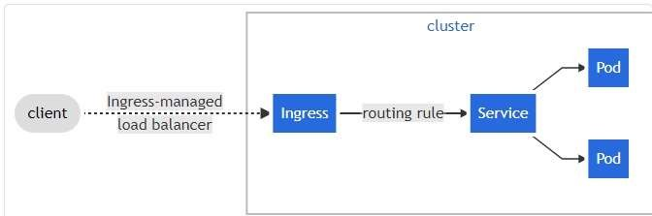

An Ingress may be configured to give Services externally-reachable URLs, load balance traffic, terminate SSL / TLS, and offer name-based virtual hosting. An [Ingress controller](https://kubernetes.io/docs/concepts/services-networking/ingress-controllers) is responsible for fulfilling the Ingress, usually with a load balancer, though it may also configure your edge router or additional frontends to help handle the traffic.

An Ingress does not expose arbitrary ports or protocols. Exposing services other than HTTP and HTTPS to the internet typically uses a service of type [Service.Type=NodePort o](https://kubernetes.io/docs/concepts/services-networking/service/#nodeport)[r Service.Type=LoadBalancer.](https://kubernetes.io/docs/concepts/services-networking/service/#loadbalancer)

**Try Kubernetes:**

There are many ways to install Kubernetes.

1. **Manual** means that you manually set up everything from the networking bits over downloading, configuring and launching components such as etcd or kube-apiserver. You've got full control over what goes where, but it might take you some time and it's error-prone. The ultimate reference in this area is Kelsey Hightower's [Kubernetes The Hard Way (](https://github.com/kelseyhightower/kubernetes-the-hard-way)KTHW).

1. **Installer** are CLI tools that leverage templates and/or automation tools such as Terraform and Ansible. You typically have a lot control over what is going on, but less than in the manual approach. Examples include:
   * OpenCredo's Kubernetes from scratch to AWS with Terraform and Ansible
   * [kubeadm (](https://kubernetes.io/docs/setup/independent/create-cluster-kubeadm/)bare metal installation, a building block for other installers)
   * [kops,](https://github.com/kubernetes/kops) mainly AWS (AWS also provide service for kubernetes: EKS – Elastic Kubernets Service) • [kubicorn](https://github.com/kris-nova/kubicorn)
   * [kubespray (](https://github.com/kubernetes-incubator/kubespray)Ansible-based, both bare-metal and cloud)
   * OpenShift [advanced install](https://docs.openshift.org/latest/install_config/install/advanced_install.html#install-config-install-advanced-install) based on Ansible
2. **Hosted** effectively means little to no installation effort on your end. For example:
   * [Azure Container Service (](https://docs.microsoft.com/en-us/azure/container-service/kubernetes/)ACS) with Kubernetes
   * [Google Container Engine (](https://cloud.google.com/container-engine/)GKE)
   * [IBM Bluemix Container Service](https://www.ibm.com/cloud-computing/bluemix/containers)
   * [OpenShift Online (](https://www.openshift.com/pricing/index.html)OSO)
3. [Minikube o](https://github.com/kubernetes/minikube)r [Minishift –](https://www.openshift.org/minishift/) Virtualized Environemnt for Kubernetes

➢ **Setup Single Node Kubernetes Cluster with Minikube**

1. Installing Minikube -> <https://kubernetes.io/docs/tasks/tools/install-minikube/>

Install Virtualbox latest edition.

1. Setting up Minikube on virtualbox -> <https://kubernetes.io/docs/tasks/tools/install-minikube/>You will need to keep the minikube in the PATH both on Windows/Linux. Use the following instruction to setup single node Kubernetes cluster

minikube start --driver=virtualbox You can also set custom configuration like

minikube start --driver=virtualbox --cpus=2 --memory=4096m

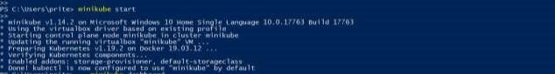

1. Open the minikube dashboard with following command. It will take 2-10 mins depending on your bandwidth.

minikube dashboard



1. The dashboard will open in your default browser

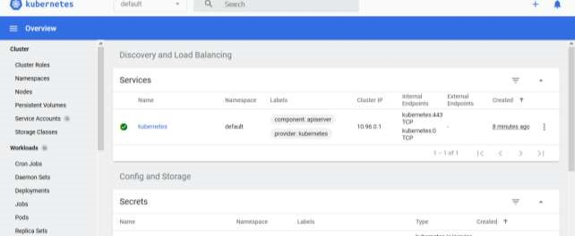

5)

On the right side corner you will see a symbol for

, click on it, and go to

-

>

Create from form

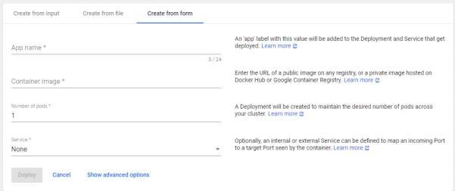

1. Enter the details as below App Name: nginx

Container image: nginx

Number of pods: 1

Service: External

Port: 80

Target Port: 80

Protocol: TCP

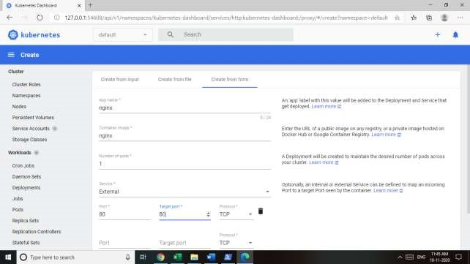

Click Deploy

1. Now you will see something like this,

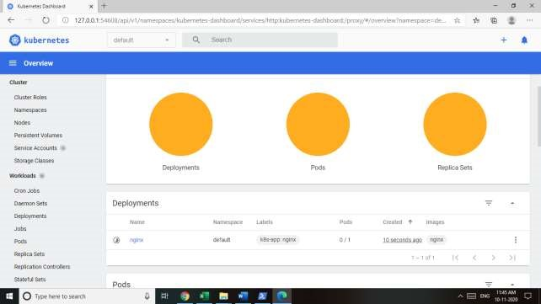

Wait for it to turn green.

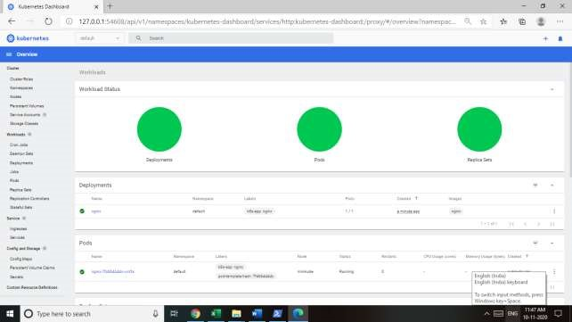

You will see the details for deployment below.

1. Access the nginx application in your browser with following command.

minikube service nginx

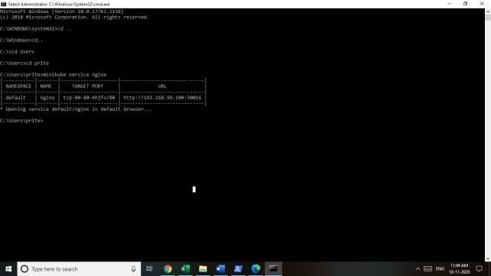

The nginx default page will open in browser and you will see the service details as well.

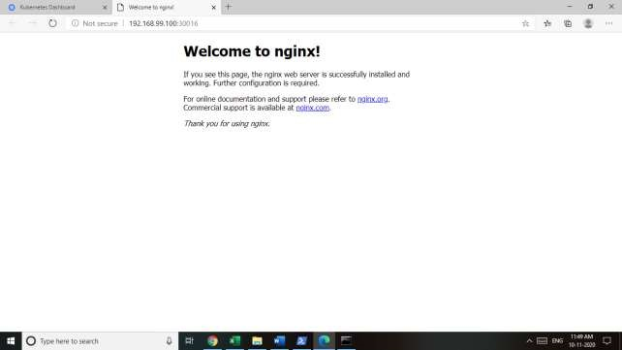

**Conclusion**: Setup of Single Node Kubernetes Cluster with Minikube was successful.